Roles Reversed

# 

You are the regional district manager of the local evil horde. But the hero is kinda cute…

# The main idea:

You are the regional district manager of the local evil horde. Your boss wants you to deal with some pesty little heroes by sending the troops in their direction. It is a simple desk job. The available troops come in, zou send them out in a way that makes sense and kills the hero. Easy. But damn! They kinda cute???? Maybe just send some easier monsters to scare them off but not kill them? Oh no they are still going… Thez look a little hungry though, maybe you should send them a snack? The boss won’t like that though… Guess you have to smuggle it to them using the horde. Hopefully they survive your romantic gift.

# Goal:

Manage the evil horde in a way that keeps the hero alive and possibly even makes them fall in love with you?

There are several rounds with different round specific goals which need to be completed in order to advance.

Example:

* Tutorial: send in some units
* Do damage to the hero (but obv don’t kill)
* Send in multiple units at once
* Do more damage to the hero (get the hero below ⅓ health)
* Send in a lot of units (idk 20)
* Send in specifically deadly units (would kill on their own but good timing of attack ups/food/potions/??? Beforehands might help)

# Mechanics:

You see various troops/ evil monsters that are available and choose the unit you want to send out to the heroes. That is actually the gameplay lol.

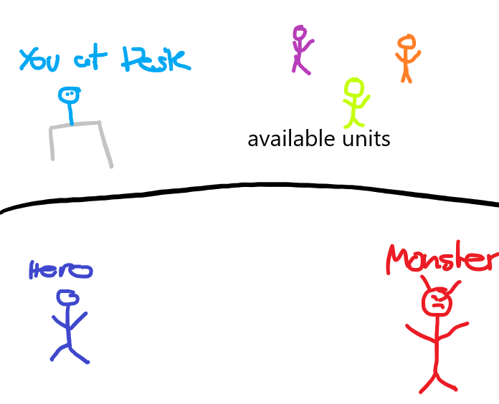

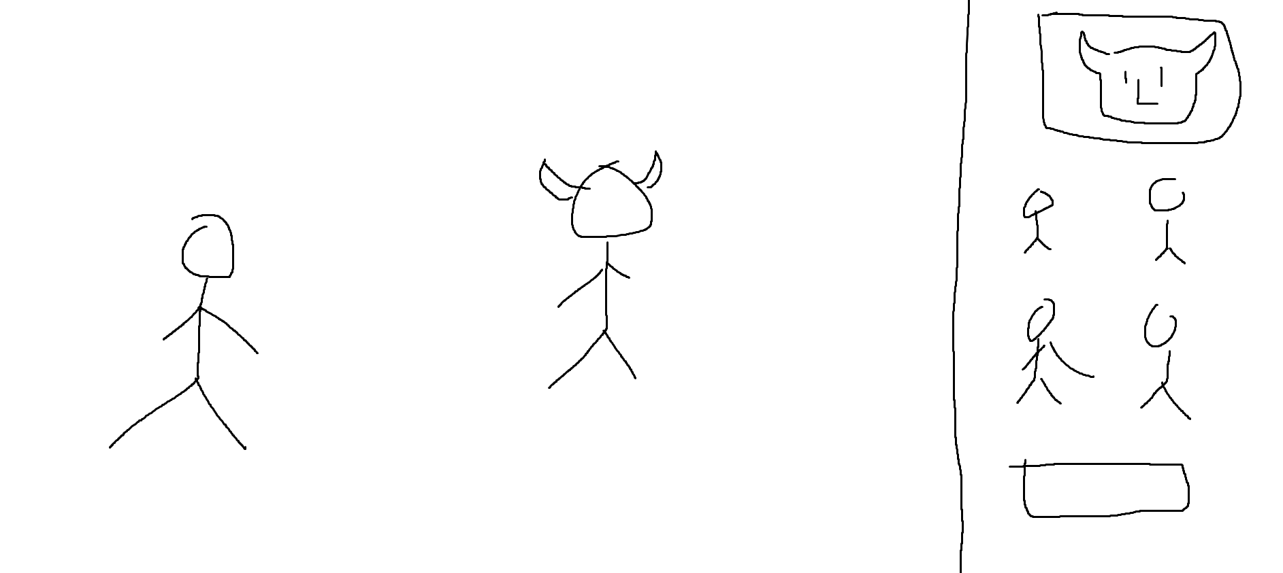

The hero has various stats which determine whether they are alive and how strong they are etc.

* Level
* Health
* Hunger
* Romance? Jk unless…?
* Attack (calculated from other values)

(Mid-hunger and mid-health gives a modifier of 1, less gives mod less than 1, more gives mod more than 1. Modifier is applied to strength to calculate attack, so f(health)xh(hunger)xstrength = attack)

Fun but also a bit more complicated to math for the player? Depending on whether we want the player to fully calculate all the values, just display the current “attack” above the player fair, Ah ok yes I like this!

The Units have stats too:

* HP
* Attack
* Patience

I am thinking: The hero always attacks first and does damage in the height of the attack stat.

If a monster survives then the monster attacks in the same way and so on.

The units can also carry items

* Health potion/ medicine
* Food (banana, eggplants, cucumber)
* Flowers
* A box of chocolates?
* A weapon
* A level up candy?
* Maybe some special power ups? Super strength, a shield, etc…?

The effects of these items are instant because inventories stink

# Monster Units

Food Unit

**Banona**

Health Potion

**Doctor**

Romance

**Flowers**

Impatient enemies

**Dog**

Basic has nothing

**Basic**

**Stronger**

Slight redesign of basic

Super Stronk also impatient

**STRONK_DUCK**

# Scenes

Cutscene for each Cutscene

Fight landscape for each Level

Menu

Loss screen ?

Final cutscene

# Story

## Cutscene 0

You start your job at the evil horde management bureau with a new assignment from your big evil boss:

**New threat spotted at the eastern border! Some idiot wants to invade HQ and foil our evil plan™! Coordinate the troops to eliminate the intruder.**

**1 Attachment.**

There is a picture attached. You open it.

//this would go into the tutorial then

*Oh dang, that threat looks pretty cute… *blush\**

*Kind of a shame to kill someone that good looking…*

*Maybe I can just scare them away without anyone getting hurt?*

## Fight 0 Tutorial

Objective: Send a monster unit to fight the hero

Units available:

* Basic Unit
* Stronger Unit

Prompt (?): Choose the unit which will not kill the hero

The player clicks a unit

The corresponding unit goes to fight the player

IF strong

Hero dies

Sadness

Restart

IF weak

Monster dies

Happiness

Next level

## Cutscene 1

Your boss is not happy that the threat has not been taken care of yet. You read the angry email.

**Per my last email, there seems to have been a miscommunication. This matter now has top priority. Resources are available as necessary, utilize them.**

## Fight 1 Tutorial2

Objective: Send out 10 units to fight the hero

Concepts introduced:

* Hero stats (Hunger, Strength)
* Items (non-romance)

Units available: 4 at a time (maybe in fixed positions)

* Basic
* Stronger
* Banona
* Doctor

The enemies available at the beginning need to be balanced so that the hero definitely takes some damage (not too much)

Prompt: *Oh no! They are hurt! They need a doctor!*

Doctor appears as one of the options.

A few more enemies get sent. The hero gets hungry.

Prompt: *Hmm, it seems like they are getting hungry…*

Banana appears as one of the options

## Cutscene 2

A new email

**Just had a chat with HR, maybe cool it with the bananas? Some troops feel like their talents are benefiting the wrong side. Please correct the course of action.**

## Fight 2 Using items

Objective: Use a maximum of 5 support troops (send out 20 units in total)

Units available: 4 at a time

* Basic
* Stronger
* Banona
* Doctor

This fight should be constructed in a way that makes it absolutely necessary to use the items at the right time.

At some point the Hero will level up in this level.

*Oh it looks like they got stronger! Aren’t humans adorable?*

## Cutscene 3

**You have been scheduled for a performance review. Please demonstrate your ability to contribute to the task at hand and prove your commitment to evil plan™.**

## Fight 3 Cutting it close

Objective: Get the hero very close to death (below ¼ Health)

Units available: 4 at a time

* Basic
* Stronger
* Banona
* Doctor

## Cutscene 4

**Based on your successful performance review I am adding additional responsibilities to your position. New troops are coming in but they are missing corporate training and can be impatient and difficult to work with.**

## Fight 4 Tutorial3

Concepts introduced:

* Impatience

Objective: Send out 20 Units

Units available: 4 at a time

* Basic
* Stronger
* Banona
* Doctor
* Dog (impatient)

Those dogs sure can’t wait to get into battle.

## Cutscene 5

**HR has let me know that there will be no additional compensation for these responsibilities. Nonetheless, we expect you to keep up with your previous duties as well. Project Kill Hero must be completed.**

## Fight 5 Working with Impatience

Objective: Send out 20 Units without any getting impatient

Units available: 4 at a time

* Basic
* Stronger
* Banona
* Doctor
* Dog

## Cutscene 6

**The Hero is rapidly approaching HQ. In order to ensure continuity of evil plans™, we must eliminate them before they reach our gate. In case of failure, you will be held accountable.**

*They might come here? It would be nice to meet them in person… *blushes\**

## Fight 6 Romance???

Objective: Send out 20 Units

Concepts introduced:

* Romantic items

Objective:

Units available: 4 at a time

* Basic
* Stronger
* Banona
* Doctor
* Dog
* Flower

I think it would be cool to have the flower guy come in pretty late

When the flower dies the romance meter appears

*Wait, do they think I’m flirting with them??? *blushes\**

## Cutscene 7

**I’m out of the office preparing evil plans™ and will be back at [Date of Return]. During this period I will have limited access to my email. Please deal with any problems through hand-to-hand combat.**

*Guess I can choose my own objectives today…*

## Fight 7

Objective: Increase the romance level up to 30 (or idk)

Units available: 4 at a time

* Basic
* Stronger
* Banona
* Doctor
* Dog
* Flower

## Cutscene 8

**As a mandatory team-building exercise I am requesting that all units be sent out in teams of two. It is important that we all find partners we can really rely on ahead of the evil plan™ launch.**

## Fight 8 Time to romance harder

Objective: Have three units in battle at all times (until you are out of units idk 20 or something)

Units available: 4 at a time

* Basic
* Stronger
* Banona
* Doctor
* Dog
* Flower

## Cutscene 9

**Just wanted to touch base regarding project Kill Hero, due to increasing urgency I require a status update ASAP!**

## Fight 9 Wow the boss is really mad

Objective: Send out 5 Stronk ducks

Units available: 4 at a time

* Basic
* Stronger
* Banona
* Doctor
* Dog
* Flower
* STRONK DUCK

## Cutscene 10

**FINAL DEADLINE: Deliverable due! Hero quite literally knocking at our door, last chance to avoid disaster and make sure evil plans™ can go ahead as planned. All units are available and at high alert. DO NOT DISAPPOINT ME.**

## Fight 10 FINAL FIGHT

Objective: Send out all units

This one is long and difficult

Units available: 4 at a time

* Basic
* Stronger
* Banona
* Doctor
* Dog
* Flower
* STRONK DUCK

## Cutscene Final

The Hero walks up to your desk and gives you a little smooch, you run away into the sunset and the evil plan still happens, everybody wins.

# Math Balancing

Amount xp divided by 10 = level

Each opponent gives 1xp?

Each level gives +10 HP and +2 Attack and +5 Food ???

## Fight 0

Hero Level 1

* HP 100
* Attack 10

Basic:

* HP 50
* Attack 10

Skull:

* HP 200
* Attack 50

When defeating a basic enemy, the hero therefore takes 50 damage

List

1. Basic
2. Stronger

## Fight 1

Hero Level 1

* HP 100
* Attack 10
* Food 100

Basic:

* HP 50
* Attack 10

Skull:

* HP 200
* Attack 50

Doc:

* HP 200
* Attack -10 (healing)

While defeating the doctor the hero heals 200 HP

Banona:

* HP 100
* Attack 5
* Food +100

When defeating a basic enemy, the hero therefore takes 50 damage (that might be too much lol)

List:

1. Basic
2. Stronger
3. Stronger
4. Basic
5. Doctor (This should maybe trigger a text?)
6. Basic
7. Banona (Also trigger a text?)
8. Doctor
9. Basic
10. Banona
11. Basic
12. Doctor
13. Basic
14. Stronger

## Fight 2

At some point the Hero will level up in this level.

Hero Level 1

* HP 100
* Attack 10
* Food 100

Hero Level 2

* HP 110
* Attack 12
* Food 105

Basic:

* HP 50
* Attack 10

Skull:

* HP 200
* Attack 50

Doc:

* HP 200
* Attack -10 (healing)

While defeating the doctor the hero heals 200 HP

When Hero Level 2 defeats doctor it heals 170 HP

Banona:

* HP 100
* Attack 5
* Food +100

When defeating a basic enemy, the hero therefore takes 50 damage (that might be too much lol)

Level 2 hero takes

List:

1. Basic
2. Stronger
3. Doctor
4. Basic
5. Basic
6. Banona
7. Doctor
8. Basic
9. Stronger
10. Basic
11. Doctor
12. Banona
13. Basic
14. Stronger
15. Basic
16. Doctor
17. Basic
18. Banona
19. Stronger
20. Doctor
21. Basic
22. Basic
23. Banona
24. Doctor

## Fight 3

List:

1. Basic
2. Stronger
3. Doctor
4. Basic
5. Basic
6. Banona
7. Doctor
8. Basic
9. Stronger
10. Basic
11. Doctor
12. Banona
13. Basic
14. Stronger
15. Basic
16. Doctor
17. Basic
18. Banona
19. Stronger
20. Doctor
21. Basic
22. Basic
23. Banona

## Doctor

# TODO

* ~~hero pushing~~
* ~~Make blushing animation for Greg~~
* Make final cutscene
* Create enemy list for each level
* Countdown for impatient enemies
* Make cutscenes

Accounting for Love

Crushing (on) your enemy